**Llangewydd Junior School – Ysgol Iau Llangewydd**





**Sunshine & Rainbow - What will we be learning about this term?**

Our topic this half term is ‘Dragons & Castles’. We hope to cover as much of the content, skills and experiences shown below as possible but this may change as Pupil Voice leads our learning into other areas.

**Science and Technology**

**Mathematics and Numeracy**

**Languages, Literacy and Communication**

* Look at materials and investigate their properties.
* Build a castle using a range of construction materials e.g. Lego.
* Build a dragon using recyclable materials.
* Have a royal banquet.
* **DCF –** Build a castle using digital software such Minecraft.
* Create a ppt on recycling to present in assembly.
* Use puppet pals to retell a famous story about a castle.
* Copy/paste digital images to support the above.
* Co-ordinates – finding different castles on a map of Wales.
* Direction – using Beebot to move in different directions.
* Measure – Measuring the distance they can catapult a small object. Creating a table of results.

**Spring Term 1 2025**

**Sunshine & Rainbow**

**Dragons & Castles**

* Write a story about a local castle.
* Design posters to promote recycling in the school and local community.
* Listen to and read a range of stories about castles and dragons.

* **Welsh** – Read the Welsh story ‘Cantre’r gwaelod.’
* Welsh legend ‘Llydd and Llefelys’ – The tale of the red & white dragon.

**Health and Well-being**

**Humanities**

Our **Four Purposes** inform all our learning:

* ambitious, capable learners
* enterprising, creative contributors
* ethical, informed citizens
* healthy, confident individuals

Cross-curricular Responsibilities inform all our learning:

**Literacy, Numeracy and**

**Digital Competency**

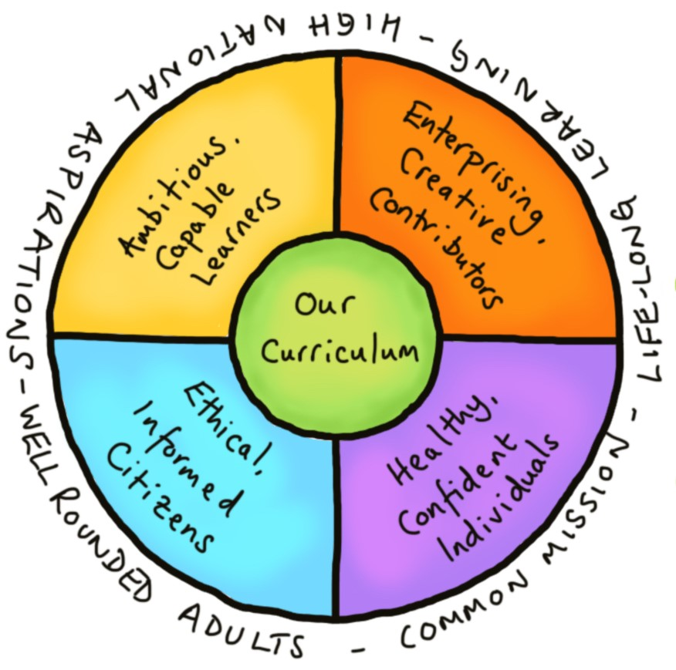

**Expressive Arts**

* Learn a medieval dance.
* Compose medieval music to accompany the dance.
* Sketch a castle of choice.
* Design their own castle – focussing on features/location.
* Design a flag and family shield for their own castle.
* Design and build a simple catapult for our Numeracy investigation.
* Folk/medieval dancing.
* Focus on the need to work together (as castle staff would).
* Resolving problems – discuss whether battle was necessary and other ways conflict could be resolved.
* **RE** - Christianity.

.

* **Outdoor activities** – Build a castle fort using natural materials.
* Find out WHY castles were built.
* Research & create a fact file on a castle of choice.
* Locating castles in Wales using a range of resources – Google Maps/Atlas/maps of Wales.
* Functions of different parts of a castle.
* Research how the above functions help during a castle attack.

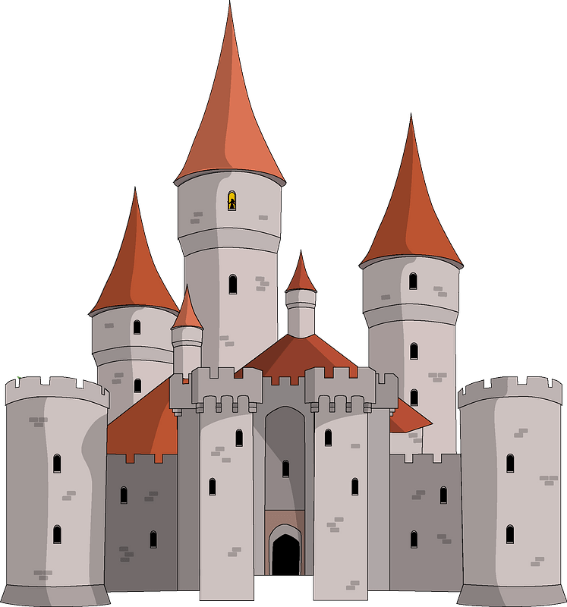



* Listen to your child reading regularly for short, sharp periods of time (avoid making reading a chore) – their Bug Club book but also real-life texts e.g. menus, leaflets, adverts…
* Support your child with any homework tasks set by their teacher.
* Help your child to learn their times tables – Revisit the x2, x5 and x10 times tables but also learn their target times table.
* Encourage your child to use at home any of the interventions they use at school i.e. Lexia (some children), Reading Eggs , Mathseeds (some children) and Mathletics (some children).
* Join/visit your local library.
* Discuss the time in your everyday lives on analogue and digital clocks.
* Ensure that your child does activities that support their well-being e.g. eating well, sleeping well, resting well.
* Spend quality time with your child simply talking to them, enjoying family experiences, playing games…



* Let us know what they would like to learn about within the topic.
* Complete any homework tasks set by their teacher.
* Bring into school any interesting items linked to our topic.
* Read regularly – their Bug Club book, real-life texts e.g. menus, leaflets, adverts…
* Practise their times tables – Revisit the x2, x5 and x10 times tables but also learn their target times table.
* Spend some time at home using any of the interventions they use at school i.e. Lexia, Reading Eggs and Mathletics (some children)or Mathseeds(some children).
* Practise handwriting – letter and number formation.
* Spend time outside playing.
* Do activities that support their well-being e.g. eat well, sleep well, rest well.

**What can I do to support my child’s learning?**

**What my child can do:**



A celebration of the work we have participated in during the term.

Our school PCSO.

Visit to Ogmore Castle (TBC)

**Our Fabulous Finish celebration event:**

**Visitors and Visits:**